**Steps To Create Devise Current Location In Android**

**Step 1 – Create a GUI with One TextView**

**Step2 – Add the permission in manifest fies**

**<uses-permission android:name="android.permission.ACCESS_FINE_LOCATION" />**

**<uses-permission android:name="android.permission. ACCESS_COARSE_LOCATION" />**

**<uses-permission android:name="android.permission.INTERNET" />**

**Step 3**

**In main activity create a Object of**

1. **LocationManager and LocationListener.**
2. **Initialize these LocationManager and LocationListener**

**LocationManager need to get the service for Loaction**

**LocationListener will create all life cycle methods.**

1. **Get the permission from user to access location of devise.**
2. **If permitted initialize the LocationManager Object with method requestLocationUpdate()🡪 4 parameters**

**1🡪LocationManager type weather GPS or Network**

**2-🡪time interval for updates**

**3🡪distance for updates**

**4🡪requestCode any integer.**

**Note🡪 parameter2,3 0,0 means immediate update without any interval.**

1. **Once done extract the values for longitude and latitude in onLocationChange methods Using getLatituge() and get Longitude() methods**

**Complete Java Code**

**In MainActivity java file**

**import** androidx.appcompat.app.AppCompatActivity;  
**import** androidx.core.app.ActivityCompat;  
**import** androidx.core.content.ContextCompat;  
  
**import** android.Manifest;  
**import** android.content.Context;  
**import** android.content.pm.PackageManager;  
**import** android.location.Location;  
**import** android.location.LocationListener;  
**import** android.location.LocationManager;  
**import** android.os.Bundle;  
  
**import** android.view.View;  
**import** android.widget.Button;  
**import** android.widget.TextView;  
  
  
**public class** MainActivity **extends** AppCompatActivity {  
  
 Button **b1**;  
 TextView **t1**;  
 LocationManager **lm**;  
 LocationListener **ll**;  
  
  
 @Override  
 **protected void** onCreate(Bundle savedInstanceState) {  
 **super**.onCreate(savedInstanceState);  
 setContentView(R.layout.***activity_main***);  
  
 **t1**=(TextView)findViewById(R.id.***textView1***);  
 **b1**=(Button)findViewById(R.id.***btnlocation***);  
 **lm**=(LocationManager) getSystemService(Context.***LOCATION_SERVICE***);  
  
  
 **ll**=**new** LocationListener() {  
 @Override  
 **public void** onLocationChanged(Location location) {  
 *//Toast.makeText(getApplicationContext(),"Longitute"+ location.getLongitude()+"Latitude"+location.getLatitude(),Toast.LENGTH_LONG).show();* **t1**.setText(**"Logitude"**+location.getLongitude()+**"Latitude"**+location.getLatitude());  
 }  
  
 @Override  
 **public void** onStatusChanged(String s, **int** i, Bundle bundle) {  
  
 }  
  
 @Override  
 **public void** onProviderEnabled(String s) {  
  
 }  
  
 @Override  
 **public void** onProviderDisabled(String s) {  
  
 }  
 };  
  
  
 *//button clicked* **b1**.setOnClickListener(**new** View.OnClickListener() {  
 @Override  
 **public void** onClick(View view) {  
 **if**(ContextCompat.*checkSelfPermission*(MainActivity.**this**, Manifest.permission.***ACCESS_FINE_LOCATION***) != PackageManager.***PERMISSION_GRANTED***)  
 {  
 ActivityCompat.*requestPermissions*(MainActivity.**this**,**new** String[] {Manifest.permission.***ACCESS_FINE_LOCATION***},1);  
 }**else** {  
 **lm**.requestLocationUpdates(LocationManager.***GPS_PROVIDER***,0,0,**ll**);*//here0,0,means within no time location will update with no time and distance we can fix tosome time and distance for battery consumption* }  
  
  
 }  
 });  
  
  
 }  
}

Output

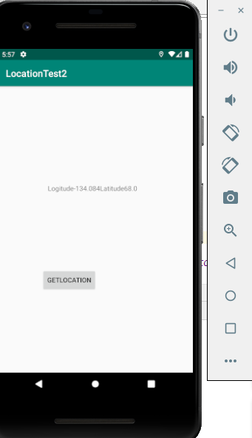

To Change the Location point of devises use the … of emulator

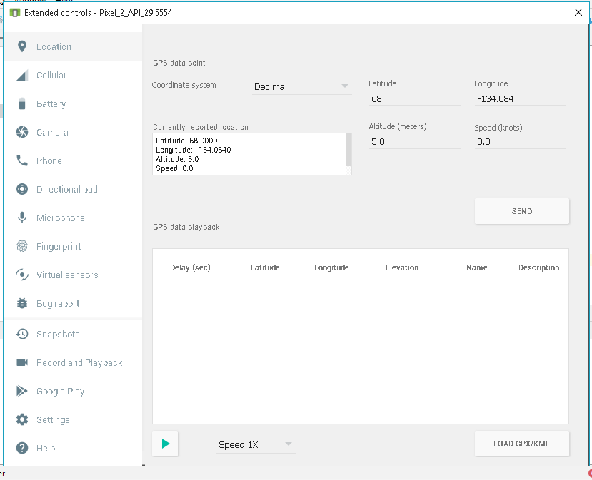

**Note –for reverse geocoding**

*//button to get address geocodin and reverse geocoding***b2**.setOnClickListener(**new** View.OnClickListener() {  
 @Override  
 **public void** onClick(View view) {  
 **try** {  
 Geocoder myLocation = **new** Geocoder(getApplicationContext(), Locale.*getDefault*());  
 List<Address> myList = myLocation.getFromLocation(**lt**, **lg**, 1);  
 Address address = (Address) myList.get(0);  
 String addressStr = **""**;  
 addressStr += address.getAddressLine(0) + **", "**;  
 addressStr += address.getAddressLine(1) + **", "**;  
 addressStr += address.getAddressLine(2);  
 **t1**.setText(**""**+address.toString());  
 Toast.*makeText*(getApplicationContext(),**""**+address,Toast.***LENGTH_LONG***).show();  
 }**catch**(Exception e){}  
  
 }  
});